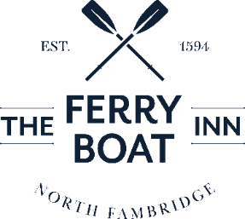

CHRISTMAS PRE ORDER
MENU
£35.95 per person

STARTERS
Roasted Parsnip Soup with ciabatta (G, M) GFA VGA
Duck Rillette served with orange salad & crostini (G, Mu) GFA
Baked Camembert served with dipping breads (G, M) GFA
Garlic & Chilli King Prawns served on toasted brioche topped with wild rocket (G, M, Cr) GFA

MAINS
Roasted Turkey, roast potatoes, shredded Brussel sprouts, parsnips, chantenay carrots, stuffing, pigs in blankets, Yorkshire pudding, gravy & cranberry sauce (G, M, E, Su) GFA
Short Rib of Beef, mustard mash potato, tenderstem broccoli and a red wine sauce (M, Mu, Su)
Can be served with the roast garnish (G, M, E, Su) GFA
Vegetarian Nut Roast, roast potatoes, shredded Brussel sprouts, parsnips, chantenay carrots, Yorkshire pudding & gravy (G, M, E, N, Su) VGA
Pan roasted Seabass, herb crushed new potatoes, green beans in a white wine cream & prawn sauce (M, F, Cr)
Wild Mushrooms & Goats Cheese Pithivier with green beans & herb crushed new potatoes (G, M, E)

DESSERTS
Classic Christmas Pudding served with brandy sauce (G, M, N, Su) GFA
Double Chocolate Yule Log served with winter berries & caramel ice cream (G, M, E)
Rhubarb & Ginger Cheesecake served with raspberry coulis (G, M)
Vegan Chocolate & Salted Carmel Brownie served with forest fruits
Classic Cheeseboard (G, M, C) GFA
TEA & COFFEE WITH PETIT FOURS (Upgrade to speciality coffee - £1.50)
Mince Pies (G, E)
Stollen (G, E)
Allergens: C – Celery, G – Gluten, Cr – Crustaceans, E – Egg, F – Fish, M – Milk, Mu – Mustard, Mo – Molluscs,
N – Nuts, Se – Sesame, S – Soya, Su – Sulphites
GFA – Gluten-free option available
VGA – Vegan option available

